**Project Title:** Gas Leakage Monitoring and Alerting System **Team ID:** PNT2022TMID30897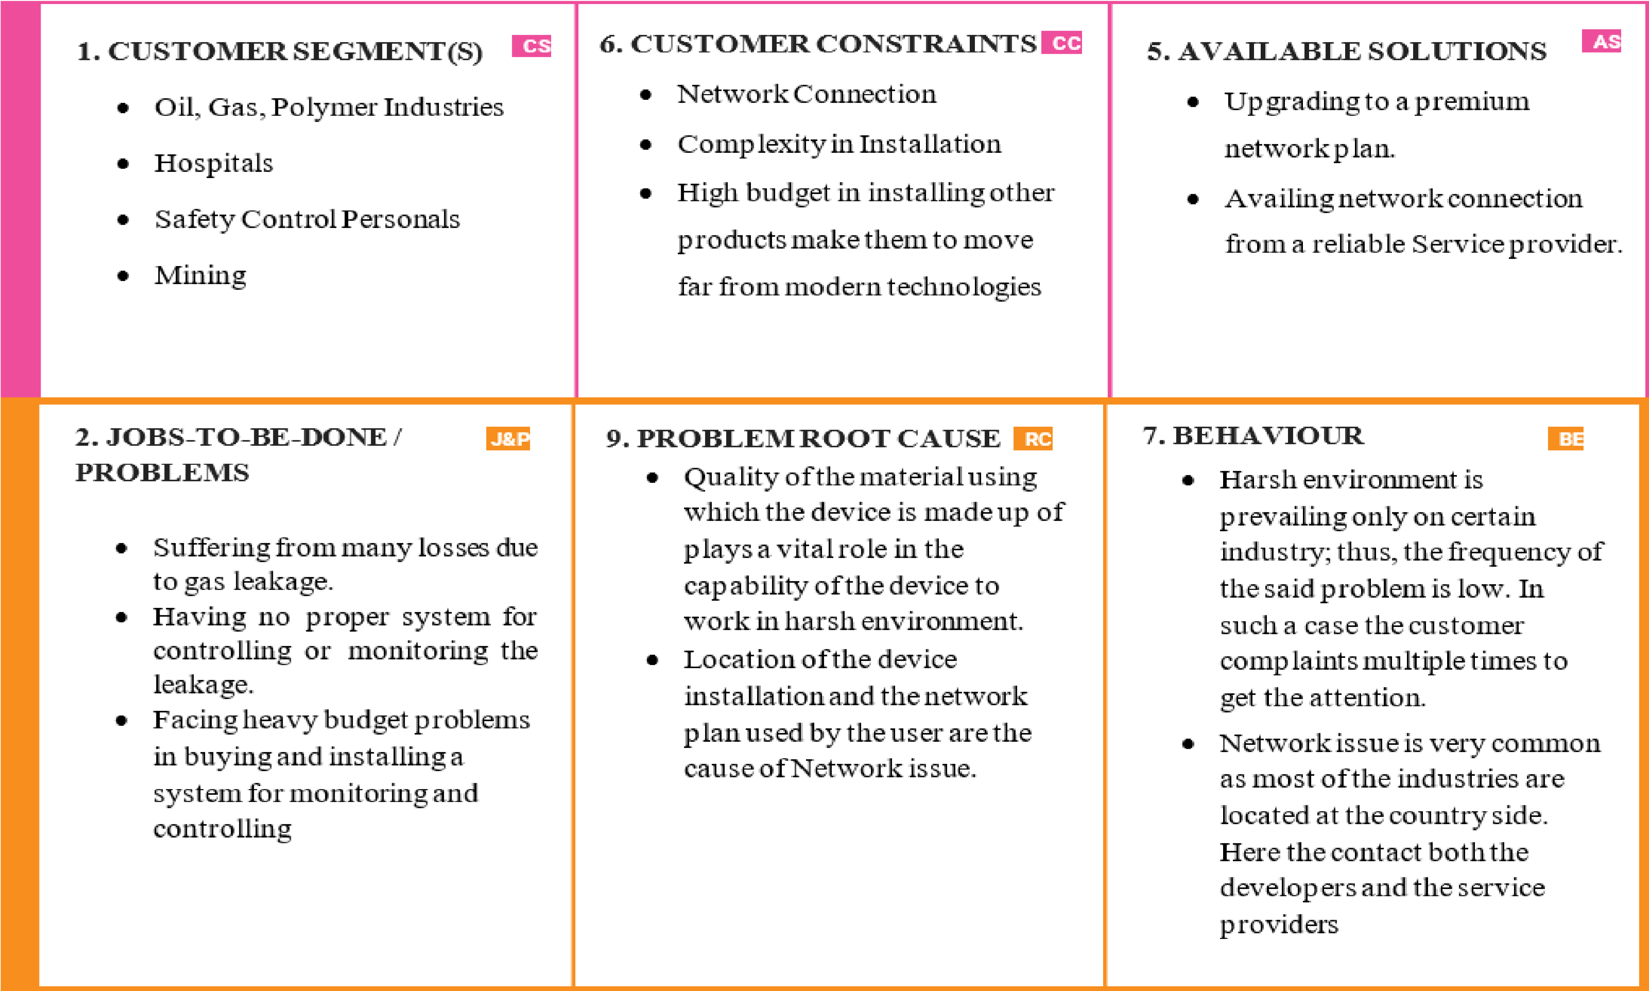

**F o c u**

**s**

**o**

**n**

**J**

**&**

**P**

**,**

**t**

**a**

**p**

**i**

**n**

